## ACCIDENT LOCATION ON INDIAN ROADS

**Karthikeyan.V**

**ARTIFICIAL INTELLIGENCE AND DATASCIENCE ENGINEERING**

[**karthikeyan.v.2021.ad@ritchennai.edu.in**](mailto:karthikeyan.v.2021.ad@ritchennai.edu.in)

**Mr.Abhishek Nandy**

**Industrial Mentor**

[**abhisheknandy@theprograms.in**](mailto:abhisheknandy@theprograms.in)

**Dr.G.Sai Krishnan**

**Institute Mentor**

**saikrishnan.g@ritchennai.edu.in**

***ABSTRACT:***

***A significant rise in road accidents, together with rising urbanization and motorization in India, have led to a high number of fatalities and injuries. For effective road safety management and the development of focused solutions, it is essential to understand the geographic distribution and characteristics of accident-prone locations. This project aims to provide a thorough examination of accident locations on Indian roads using geospatial techniques and data. The accident data was regionally visualized and analyzed using Geographic Information System (GIS) techniques, allowing patterns and trends to be found. By fusing geospatial analysis with accident data, our work contributes to a deeper understanding of the intricate dynamics of road accidents in India. It highlights the need for a spatially aware approach to solve road safety challenges and lays the foundation for future research in this field. Finally, the results of this study may contribute to lowering accident rates, saving lives, and enhancing Indians' general safety and lays the groundwork for future research in this area. Finally, the findings of this study may help to reduce accident rates, save lives, and improve Indians' overall safety.***

**Introduction:**

National highways are critical in India for facilitating trade, connecting significant cities, and boosting the country's overall economic growth. However, the increase in accidents on these roads has raised concerns about public safety and the need for strict road safety measures. Understanding the spatial distribution and characteristics of accident locations on national roads in India is critical for developing targeted interventions to minimize accidents and improve road safety.

.

**Architecture:**

* + Data collection
  + Mapping the data

# **Data collection:**

We are going to use primary as well as secondary data sources to compile in- depth statistics on traffic collisions. While secondary data will consist of demographic data, road network data, traffic volume statistics, and other pertinent variables, the main record will include accident records received from police departments and road safety departments.

## Software model:

The accident data on India will be mapped and analyzed using Geographic Information System (GIS) methods. GIS makes it possible to combine different data layers, making it easier to discover accident hotspots and patterns.

**ArcGIS:**

The widely used GIS software suite ArcGIS, created by Esri, has many features for accident location analysis. Users can examine accident data based on location, qualities, and spatial correlations thanks to its spatial analysis features. Real-time data sources can be integrated with ArcGIS, allowing for the viewing of accident locations on dynamic maps.

# **GeoDa:**

Free and simple Geographic Information Systems (GIS) program called GeoDa is created primarily for spatial analysis. It provides numerous analytical methods, such as spatial autocorrelation, cluster analysis, and kernel density estimation, for accident location analysis. Users of GeoDa can investigate and see spatial patterns of accidents, find hotspots, and evaluate the importance of spatial grouping.

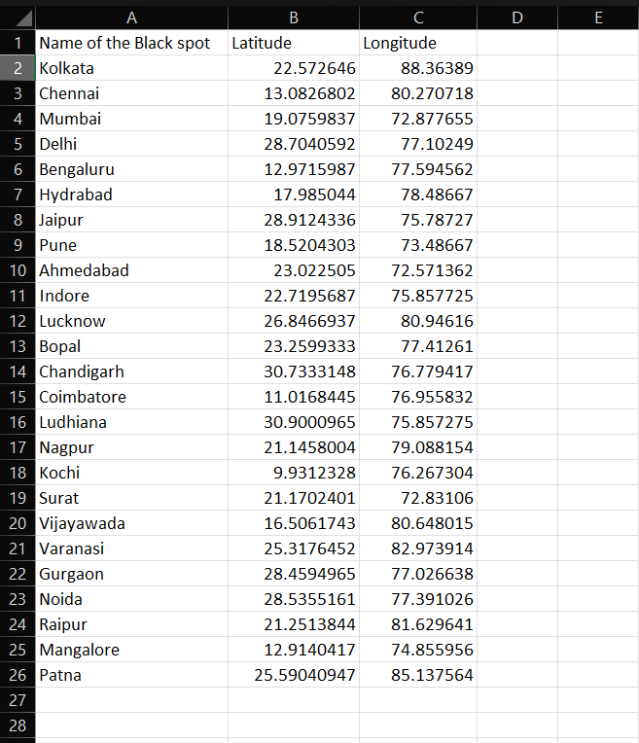

**Conclusion:**

In conclusion, a project that focuses on the locations of accidents on Indian roads can have a big impact on raising traffic safety and emergency response. The project can accomplish the following goals by utilizing cutting-edge technology including GIS software models, GPS systems, and intelligent transportation systems.

* Making decisions based on data: The initiative may offer insightful accident data for study, allowing officials to spot accident trends, high-risk regions, and contributing variables. Improvements to the infrastructure and specific road safety actions can be made using this information.
* Reduced response time: The initiative can cut down on emergency service response times by promptly locating accident sites, ensuring prompt on-site help.
* Public involvement and education: By utilizing real-time accident data, the initiative may educate the general public about traffic safety issues and promote safe driving practices. Commuters can make educated judgments and avoid accident-prone locations by sharing accident information through social media platforms and smartphone applications.

**Reference paper:**

1. Sharma N, Kumar A. *A. Road accidents in India: Dimensions and issues. [online]*. Available from: <http://www.teriin.org/library/files/Road_Accidents_in_India.pdf>.
2. *Road traffic injuries. WHO* Available from: <http://www.who.int/violence_injury_prevention/road_traffic/en/>
3. *Regional report on status of road safety: WHO South-East Asia region. [online]* [Last accessed on 2018 Dec 28]. Availabe from: [http://www.](http://www.searo.who.int/entity/disabilities_injury_rehabilitation/documents/9789290223559/en/) [searo.who.int/entity/disabilities_injury_rehabilitation/documents/9789290223559/](http://www.searo.who.int/entity/disabilities_injury_rehabilitation/documents/9789290223559/en/) [en/](http://www.searo.who.int/entity/disabilities_injury_rehabilitation/documents/9789290223559/en/)